**Reference No:** C29…..

**Damage Report Date:** .13/11/13...

**Incidents must be reported immediately.**

Damage found in Container must not to be touched until pictures have been taken to effectively demonstrate to stake holders how damage could have occurred?

In Container Container No.

In Warehouse How was it damaged? Forklift

Product

NSF555B x2 S/N I215853 ; I213800

NSC700BR x1 S/N I106663

NS125FB x1 S/N (21)I281194

*Insert* Picture:

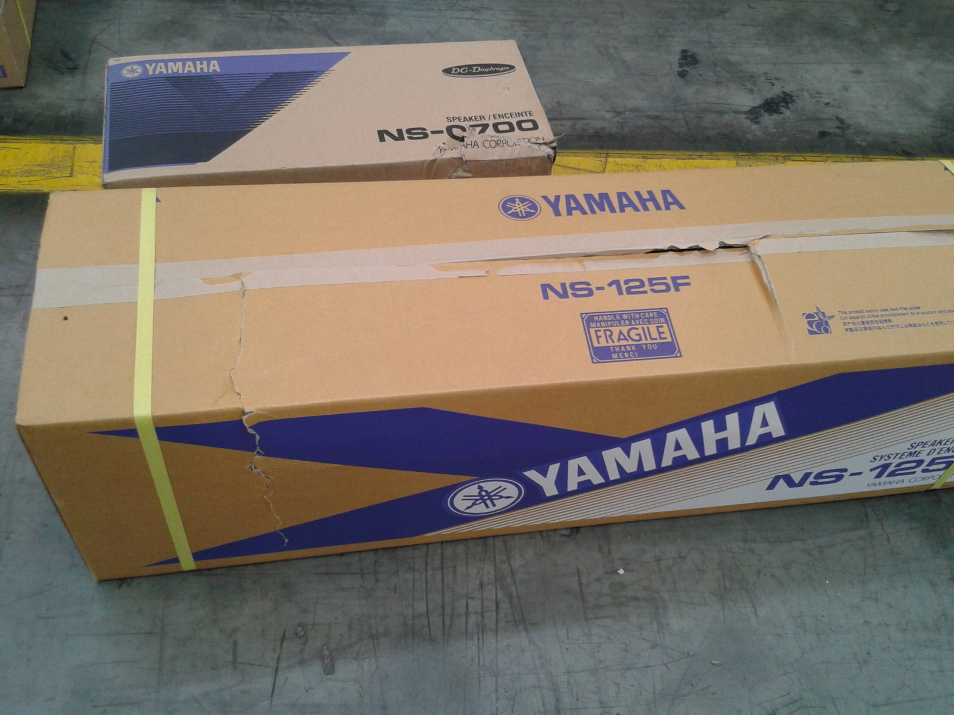

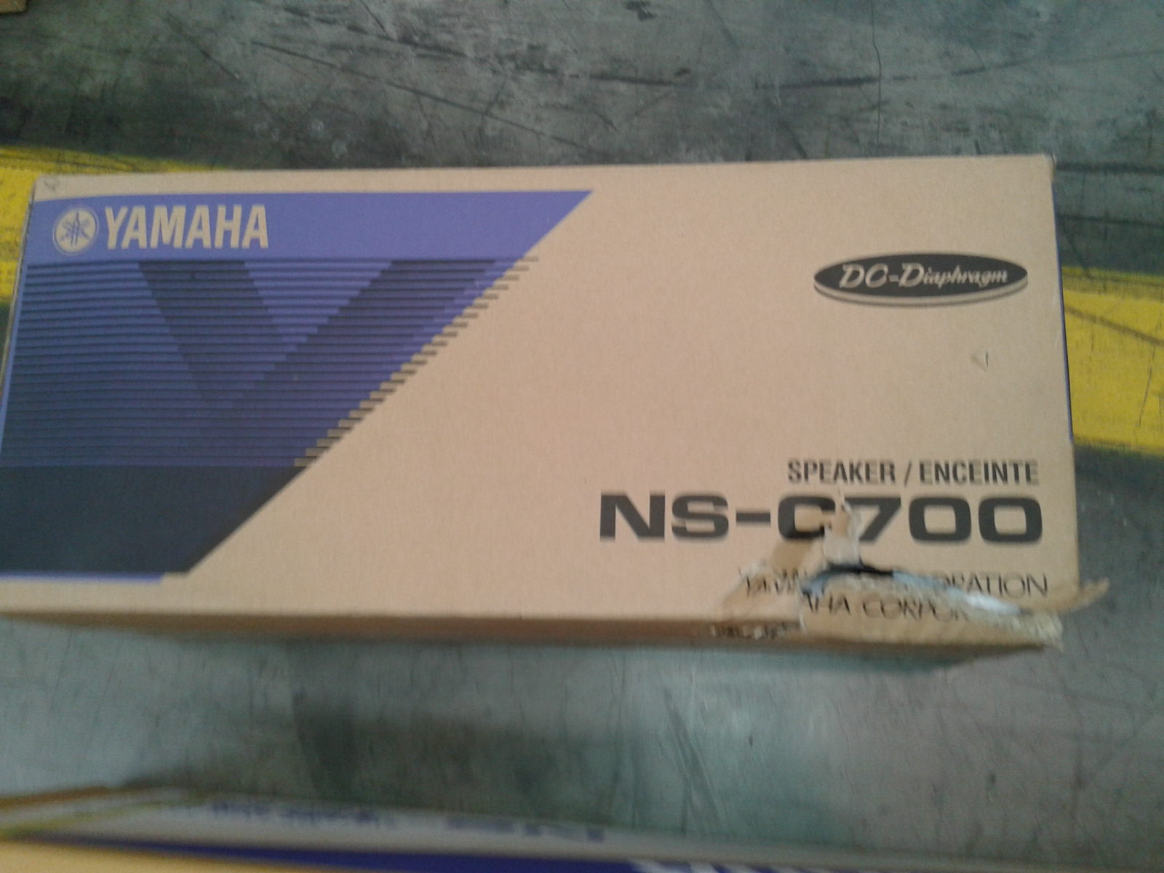

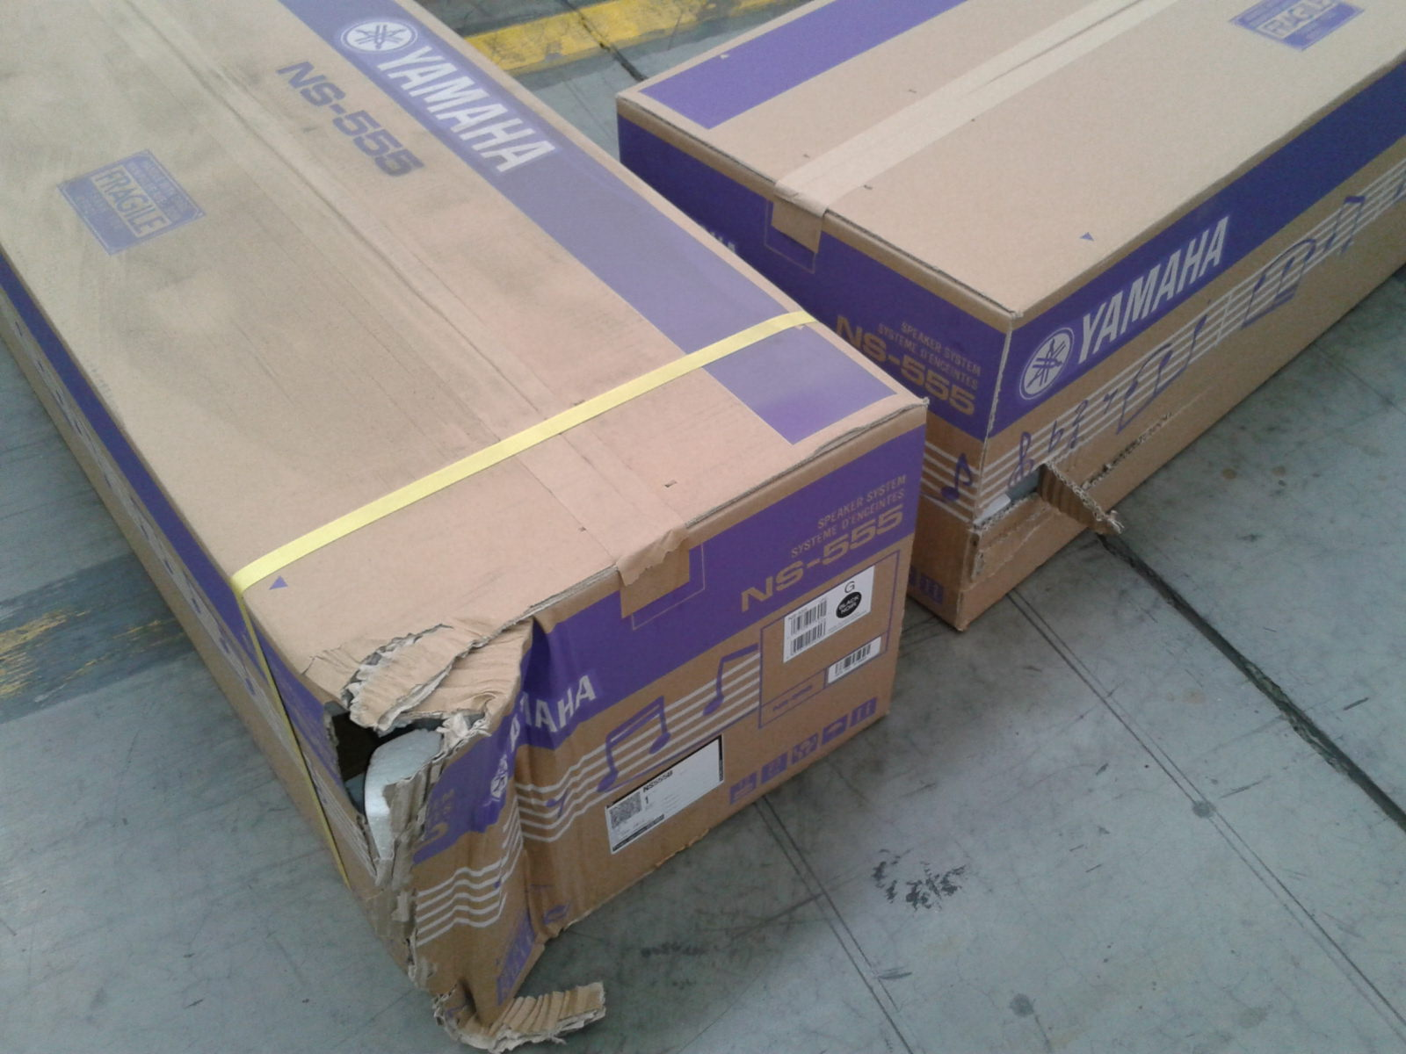

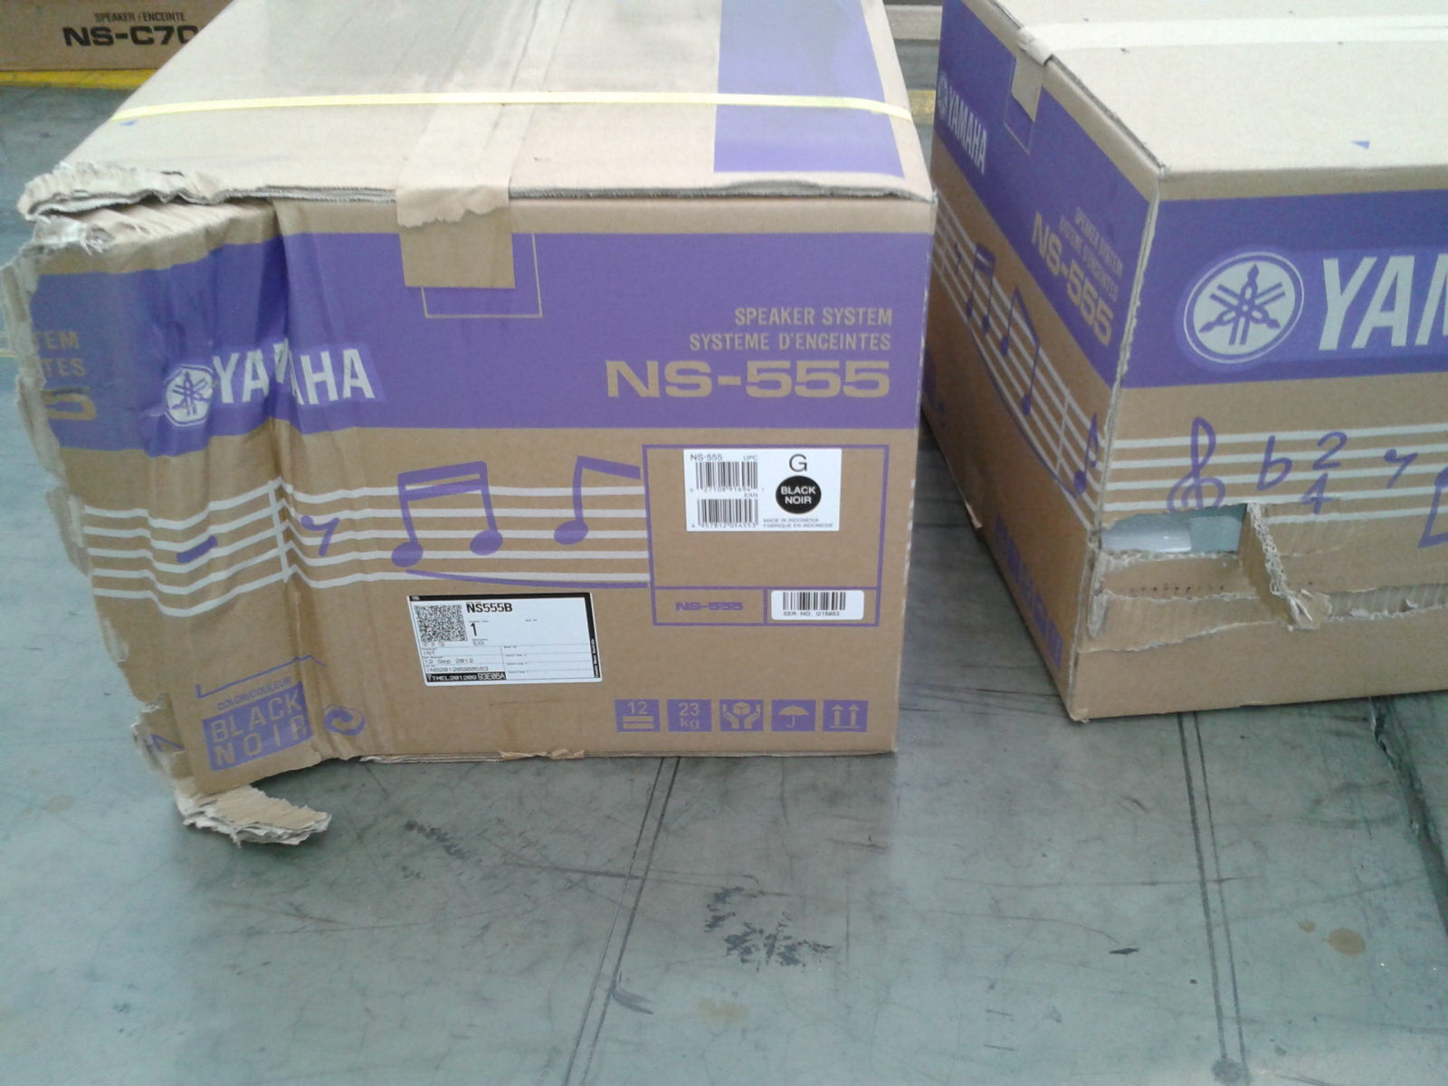

Reported by…Frank V…………………………………….